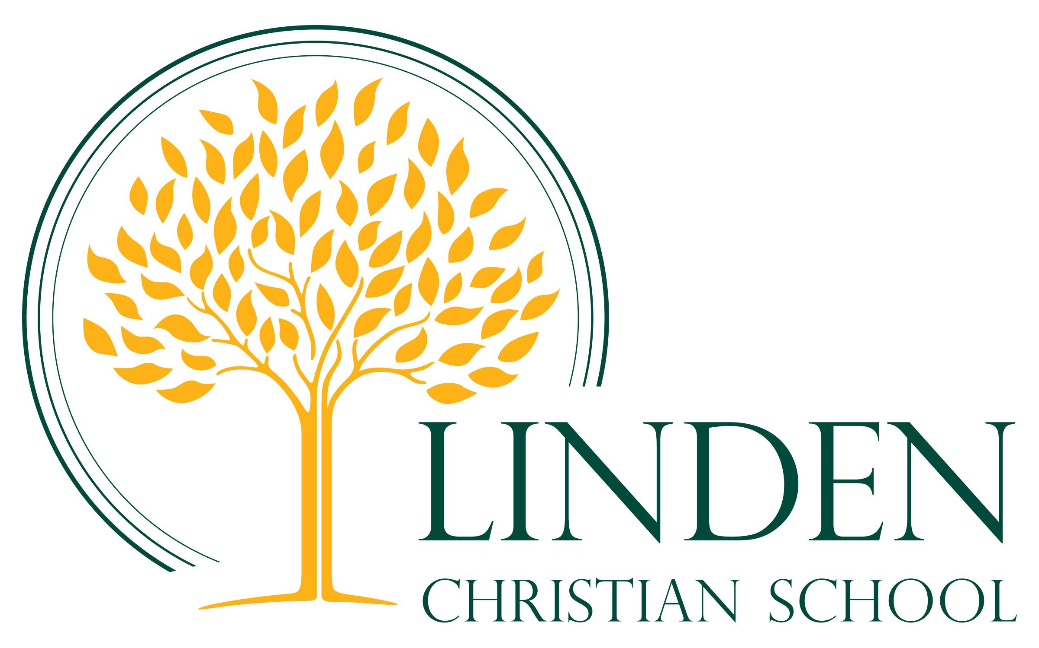

Employment Opportunity – Educational Assistant
Term Position

Linden Christian School (LCS) invites applications for the position of Educational Assistant for the 2021-2022 school year. LCS is a K-12 independent school with over 950 students. The Educational Assistant (EA) is responsible to support the work of teachers and clinicians through a range of activities dependent upon specific student needs within the learning environment. EAs are valued members of the school team and make a significant contribution to the work of the school and the education of all students.

The successful candidate will:

- have a sincere love for Jesus Christ evidenced by lifestyle, including regular attendance at weekly church services;
- give evidence of a strong commitment to Christian faith in belief and practice, and be in agreement with LCS’ Mission, Vision and Core Value statements;
- be willing to sign and adhere to the LCS Statement of Faith and Lifestyle Commitment and demonstrate confidentiality relating to all school issues.

Interested candidates will meet the following requirements:

- Certification or Diploma from a recognized Educational Assistant Program is an asset, but is not required;
- Experience working with children in an educational environment;
- Experience working with students with exceptional needs is an asset;
- Ability to work with students one-on-one and in a small group setting;
- Excellent interpersonal skills to ensure effective interactions with members of the school community;
- Ability to work within a team setting.

Interested candidates are asked to forward a letter of application, a complete résumé, a personal statement of faith and a minimum of three references. Please submit your application documents to the attention of Anne Penner, Human Resources Coordinator, via email to apenner@lindenchristian.org or by dropping them off at the LCS Administration Office.

Thank you for your interest in this position. Please note only those applicants selected for an interview will be contacted.
The closing date for applications is September 24, 2021.

